MALWARE ANALYSIS USING MACHINE LEARNING TECHNIQUES

Project Report Submitted by

Nigam N Kumar Nithin M

(4NM15CS102) (4NM15CS107)

Ronisha Glenita Saldanha Safa Suleman Shaikh

(4NM15CS139) (4NM15CS144)



UNDER THE GUIDANCE OF

Mr. Ramesha Shettigar

Asst. Professor

Department of Computer Science and Engineering

in partial fulfilment of the requirements for the award of the Degree of

Bachelor of Engineering in
Computer Science & Engineering

from
Visvesvaraya Technological University


(ISO 9001:2015 Certified), Accredited with ‘A’ Grade by NAAC
                 : 08258 - 281039 – 281263, Fax: 08258 – 281265
Department of Computer Science and Engineering


April 2019
(ISO 9001:2015 Certified), Accredited with ‘A’ Grade by NAAC
                 : 08258 - 281039 – 281263, Fax: 08258 – 281265
Department of Computer Science and Engineering

B.E. CSE Program Accredited by NBA, New Delhi from 1-7-2018 to 30-6-2021

CERTIFICATE

Certified that the project work entitled

"Dynamic Malware Analysis Using Machine
Learning Techniques”

is a bonafide work carried out by

Nigam N Kumar (4NM15CS102) Nithin M (4NM15CS107)

Ronisha Glenita Saldanha (4NM15CS139) Safa Suleman Shaikh (4NM15CS144)

in partial fulfilment of the requirements for the award of

Bachelor of Engineering Degree in Computer Science and Engineering

prescribed by Visvesvaraya Technological University, Belagavi during the year 2018-2019.

It is certified that all corrections/suggestions indicated for Internal Assessment have been incorporated in the report deposited in the departmental library.

The project report has been approved as it satisfies the academic requirements in respect of the project work prescribed for the Bachelor of Engineering Degree.

Signature of Guide Signature of HOD Signature of Principal

Semester End Viva Voce Examination

Name of the Examiners Signature with Date

- _________________________________________________________

2._________________________________________________________
ACKNOWLEDGEMENT

The satisfaction that accompanies the completion of any task would be incomplete without the mention of all the people, without whom this endeavour would have been a difficult one to achieve. Their blessings, encouragement, guidance and suggestions have been a constant source of inspiration.

First and foremost, we express our deep sense of gratitude and indebtedness to our guide Mr. Ramesha Shettigar, Assistant Professor, Department of Computer Science and Engineering for his inspiring guidance, constant encouragement, support and suggestions for improvement during the course for our project.

We would like to express a deep sense of gratitude to the project coordinators for their valuable guidance and support.

We sincerely thank Dr. K.R. Udaya Kumar Reddy, Head of Department of Computer Science and Engineering, Nitte Mahalinga Adyantaya Memorial Institute of Technology, Nitte..

We would like to take this opportunity to express our sincere thanks to our beloved principal, Dr. Niranjan N. Chiplunkar for giving us an opportunity to carry out our project work at our college and providing us with all the needed facilities.

Finally, we thank the staff members of the Department of Computer Science and Engineering and all our friends for their honest opinions and suggestions throughout the course of our project.

Nigam N Kumar

Nithin M

Ronisha GSaldanha
Safa Suleman Shaikh
\

iii
ABSTRACT

Self-driving cars are finally here, and how they are deployed will change how we get around forever. An automated driving system composed of several system components such as perception, decision making and operation of the automobile which are performed by electronics and machinery instead of Human Driver. System is introduced into road traffic. Under this process the system has to undergo handling of the vehicle, destination, as well as awareness of the surroundings. Since automated system has control over the vehicle, it allows the human operator to leave all the responsibilities to the system.
Robot Operating System is a robotics middleware that is, a collection of software frameworks for robot software development. This helps in simulating automated systems. It is not an operating system, rather it provides services designed for a heterogeneous computer cluster such as hardware abstraction, low-level device control, implementation of commonly used functionality, message-passing between processes, and package management. Running sets of ROS-based processes are represented in a graph architecture where processing takes place in nodes that may receive, post and multiplex sensor, control, state, planning, actuator, and other messages.
When it comes to simulation of a system, visualization is most important part. ROS provides a platform where we can display 3D system and monitor its moments. rviz (ROS visualization) is a 3D visualizer for displaying sensor data and state information from ROS. Using rviz, you can visualize Baxter's current configuration on a virtual model of the robot. You can also display live representations of sensor values coming over ROS Topics including camera data, infrared distance measurements, sonar data, and more.
Considering all the concepts mentioned above, we are able start with the process of simulation of self-driving cars.

iv

 |  |  |  | TABLE OF CONTENTS
Contents |  |  |  |  | Page
Title Page |  |  |  |  | I
Certificate |  |  |  |  | ii
Acknowledgement |  |  |  |  | iii
Abstract |  |  |  |  | iv
Table of contents |  |  |  |  | v
List of figures |  |  |  |  | viii
CHAPTER 1 INTRODUCTION |  |  |  |  | 1-5
1.1 |  | Overview |  |  | 1
1.2 |  | Problem Statement |  |  | 3
1.3 |  | Study Area |  |  | 3
1.4 |  | Objective |  |  | 4
1.5 |  | Motivation |  |  | 4
1.6 |  | Organization of the Report |  |  | 5
CHAPTER 2 LITERATURE SURVEY |  |  |  |  | 6-11
2.1 |  | Existing System |  |  | 6
 |  | 2.1.1 Detection Of Malwares |  |  | 6
 |  | 2.1.2 Scanning |  |  | 6
 |  | 2.1.3 Activity Monitors |  |  | 7
 |  | 2.1.4 Integrity Checking |  |  | 8
 |  | 2.1.5 Data Mining and Machine Learning Algorithms |  |  | 9
 |  | 2.1.6 Feature Type |  |  | 10
 |  | 2.1.7 Analysis Type |  |  | 10
 |  | 2.1.8 Detection Strategy |  |  | 11
2.2 |  | Proposed System |  |  | 11
v  CHAPTER 3 SYSTEM ANALYSIS & REQUIREMENTS |  |  |  |  | 12-14
3.1 | System Analysis |  |  |  | 12
 | 3.1.1 |  | Relevance of platform |  | 12
 | 3.1.2 |  | Relevance of programming language |  | 12
3.2 Requirements |  |  |  |  | 13
 |  | 3.2.1 | Scope & Boundary |  | 13
 |  | 3.2.2 | System Objective |  | 13
 |  | 3.2.3 | Input and Output |  | 13
 |  | 3.2.4 | Assumption & Dependencies |  | 13
 |  | 3.2.5 | General Constraints |  | 14

3.3 Functional Requirements 14

3.3.1 Software Requirements 14
3.3.2 Hardware Requirements 14
3.4 Non- Functional Requirements 14
CHAPTER 4 SOFTWARE APPROACH 15-16
4.1 Anaconda 15
4.2 Jupyter Notebook 15
4.3 Python 15
4.4 Pandas 16
4.5 Numpy 16
4.6 Scikit Learn 16
4.7 PEStudio 16
4.8 Tkinter 16
4.9 Amnpardaz Sandbox 16
CHAPTER 5 SYSTEM DESIGN 17-23
5.1 High Level Design Architecture 17
5.1.1 Static Engine 18
vi

5.1.2 Dynamic Engine 18

5.2 Low Level Design Architecture 19

5.2.1 Sequence Diagram/DF 19

5.2.2 Activity Diagram 21

5.2.3 Use Case Diagram 22

CHAPTER 6 SYSTEM IMPLEMENTATION 24-25
6.1 Modules 24
6.1.1 Static Engine 24
6.1.1.1 Reading_File_Header_Features.ipynb 24
6.1.1.2 Reading_DOS_Header_Features.ipynb 24
6.1.1.3 Reading_Optional_Header_Features.ipynb 24
6.1.1.4 Reading_Section_info.ipynb 24
6.1.1.5 PEHeader_classification.ipynb 25
6.1.1.6 Sections_Classification 25
6.1.2 Dynamic Engine 25
6.1.2.1 Reading_Dynamic_Features.ipynb 25
6.1.3 GUI 25

CHAPTER 7 SYSTEM TESTING 26-27

CHAPTER 8 RESULTS AND DISCUSSIONS 28

8.1 Results 28

8.2 Discussions 28

CHAPTER 9 CONCLUSION AND FUTURE WORK 29

9.1 Conclusion 29

9.2 Future Work 29

REFERENCES 30-32

vii

LIST OF FIGURES

Figure 1.1: Total number of malware samples identified by 1
McAfee Labs during 2012 to 2014
Figure 5.1: High level architecture for proposed system | 17
Figure 5.2.1.1: Scenario 1 – User Interaction with the system | 19
Figure 5.2.1.2: Scenario 2 – Working of the dynamic classifier | 19
Figure 5.2.1.3: Scenario 3 – Working of the static classifier | 20
Figure 5.2.2: Activity diagram for the system | 21
Figure 5.2.3.1: Use case diagram for data collection | 22
Figure 5.2.3.2: Use case diagram for user interaction with system | 22

Figure 5.2.3.3: Use case diagram for dynamic classifier 23
Figure 5.2.3.4: Use case diagram for static classifer 23

viii

CHAPTER 1

INTRODUCTION

  - OVERVIEW
The Internet has become an important part of our everyday life. The users of Internet face security threats caused by malwares. Malware (malicious software) refers to the programs that affect a computer system without the user’s permission and with an intention to cause damages to the system or steal private information from the system. Depending on the behavior and the way of infection, malwares are classified as viruses, worms, Trojan Horses, root-kits, spy-ware etc.
Thousands of new malwares emerge every day and the existing malwares are evolving such that it is difficult to detect them. In 2012 McAfee Labs identified more than 75 million new malware samples resulting in an average of 55,000 new instances of malware identified per day. As Figure 1 illustrates, this number has increased dramatically over the past few years. Similarly, Panda Labs reported more than 60,000 new malware samples per day in 2013 and an average of more than 73,000 per day in the first quarter of 2014.

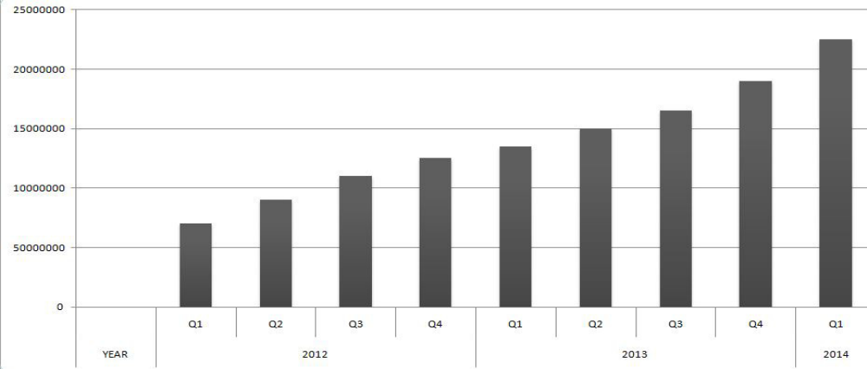
Fig 1.1: Total number of malware samples identified by McAfee Labs during 2012 to 2014

Due to this enormous rate at which samples are emerging every day, there is a growing need for automated malware analysis tools and methods in order to distinguish malicious softwares from the benign ones. Most of the commercial anti-malware softwares today use signature based malware classification method. It is a method of identifying unknown malware programs by comparing them to a database of known malware programs. The signature is a unique identification of a binary file. Because new malwares are being generated each day, the signature based detection approach requires frequent updates of the virus signature database which is the main disadvantage of the method.

Malware analysis is generally carried out using two techniques, namely, Static Analysis and Dynamic Analysis. In static analysis features are extracted from the binary code of programs and are used to create models describing them. The models are used to distinguish between malware and benign software. The static analysis fails at different code obfuscation techniques, zero day attacks, polymorphic and metamorphic code techniques. But there are advantages to static analysis that the executable contains very useful information such as the PEHeader details, Sections details, Imports and Exports made etc, which can help in determining the intent of the program.

On the other hand code obfuscation techniques and polymorphic malwares fail at dynamic analysis because it analyses the runtime behavior of a program by monitoring the program while in execution. But there are some limitations to dynamic analysis. Each of the malware sample must be executed within a secure environment for a specific time for monitoring the behavior. The monitoring process is time consuming and it can result in the infection of the platform. Also, the secure environment such as a sandbox or a virtual OS is quite different from a real runtime environment and the malware may behave in different in the two environments, causing an inexact behavior log of the malware. But dynamic analysis is a necessary complement to static approach. Both static and dynamic methods have their own advantages and disadvantages. So a combined method that utilizes both static and dynamic features will be promising in the malware classification.

  - PROBLEM STATEMENT
The aim of the project is to develop an automated system capable of performing malware analysis and detection using machine learning techniques.

The traditional methods of signature based detection are capable of detecting malwares whose signature have been previously stored in the database. However, it is incapable to detect the new variants or the polymorphic variants of the existing malwares. Here we employ machine learning techniques to train the system with the feature set built from features extracted from the static and the dynamic engine. The static analysis engine checks for features such as the PEHeader information, sections information while the dynamic analysis engine runs the files in a sandbox which monitors the behavior of the program. The sandbox provides a detailed information about the system calls made, the registry and file system modifications made.

  - STUDY AREA
This project focuses on two major trending areas in the field of computer science, namely, malware analysis and detection and Machine Learning.

Malware Analysis is the study or process of determining the functionality, origin and potential impact of a given malware sample such as virus, Trojan, rootkit or backdoor. Malwares are designed with the intent of harming the host operating system or stealing sensitive data from the users. They also include software that gathers user information without permission. The method by which malware analysis is done generally falls under two categories- Static Analysis and Dynamic analysis. Static analysis is done by dissecting the different resources of an executable file without executing the code. On the other hand, Dynamic analysis is performed by analyzing the behavior of the malware while it is in execution. Here we use both the techniques for developing the system.

Machine Learning is the scientific study of algorithms and statistical models that computer systems use to effectively perform a specific task without using explicit

Instructions, relying on patterns and interference instead. It is a subset of a Artificial Intelligence. Machine Learning algorithms build a mathematical model of the training data in order to make decisions without being explicitly programmed to perform the task. There are different types of machine learning algorithms. In this project we use the approach of supervised learning. Supervised learning algorithms build a mathematical model of a set of data that contains both the inputs and the desired outputs.

  - OBJECTIVE
- To create a corpus of malware and benign files so as to efficiently train the machine learning algorithm.
- Design of a Static engine that performs static analysis of the executable and returns static features of the resources.
- Design of a Dynamic engine that performs dynamic analysis of the executable and returns the dynamic features.
- Creation of the static features dataset and development of the static classifier.
- Creation of the dynamic features dataset and development of the dynamic classifier.
- Usage of the static and the dynamic classifier to predict the maliciousness of the software with a high accuracy rate.

  - MOTIVATION
Both malware analysis and machine learning are the major trending fields of Computer Science. Malwares play a part in most computer intrusion and security incidents. With millions of malicious programs in the wild, and more encountered every day, malware analysis is critical for anyone who responds to computer security incidents. Due to the shortage of malware analysis professionals and machine learning model developers, these skills are in high demand. Moreover, due to the enormous rate at which evolving malicious softwares are being developed, there is the growing need to develop an automated system that detects malware with a high accuracy rate.

  - ORGANIZATION OF THE REPORT
Chapter 1 Introduces the main purpose of the project, provides an overview, states the problem statement and the objectives, specifies the area of study and the motivation for the up taking of the project.
Chapter 2 deals with the literature survey wherein the existing system and the proposed system are discussed.
Chapter 3 deals with the system analysis and design of system requirements such as the functional and the non-functional requirements.
Chapter 4 discusses the software approach for the design of the system.
Chapter 5 deals with the system design and architecture design.
Chapter 6 deals with the system implementation and the various modules involved.
Chapter 7 deals with system testing and the result of the various tests made.
Chapter 8 deals with the results obtained and the discussions regarding the interpretations derived from them.
Chapter 9 deals with conclusions and the scope for future work.

.

CHAPTER 2

LITERATURE SURVEY

  - EXISTING SYSTEM
This survey investigates the dynamic and static methods developed so far for malware detection. Both traditional signature based detection and generalized approaches can be used to identify these malicious programs. To avoid detection by the traditional signature-based algorithms, a number of stealth techniques have been developed by the malicious code writers. The inability of traditional signature based detection approaches to catch these new breed of malicious programs has shifted the focus of virus research to find more generalized and scalable features that can identify malicious behavior as a process instead of a single signature action.

We follow a hierarchical approach to present the literature survey and it comprises of four basic layers. Every malware detection program studied can be classified into four categories – Scanning, activity monitoring, integrity checking and the machine learning or the data mining techniques used.

2.1.1 Detection of Malwares
Most of the previous work involves the first three steps – the scanning, activity monitoring and integrity checking whereas the recent ones try to focus and emphasize on the usage of data mining and machine learning algorithms to enhance the performance of dynamic malware detection

2.1.2. Scanning
Scanning is a widely used industry standard in the anti-malware softwares and applications developed. It involves searching for strings in files. The strings being searched are pre-defined virus signatures and support exact matching as well as wildcards to look for variants of a virus. The scanners have matured from simple string scanning to heuristic scanning.
- [10] reviewed a number of scanning techniques in his book including string scanning, that is simply exact string searching, wildcard scanning, that allows for wildcards to cover variants (signatures with slight modification), smart scanning, that discards garbage instructions to thwart simple mutations, nearly exact identification, that accompany the primary virus signature with a secondary one to detect variants, exact identification, that uses as many secondary signatures as required to detect all the variants in a virus family and heuristic scanning, that scans for malicious behavior in the form of a series of actions.
- [20] used the mixed approach in their Bloodhound technology where they supplement static analysis with code emulation in their heuristic scanner. The scanner isolate logical region of the target program and analyze the logic for each region for a virus like behavior.
- Symantec’s Striker technology [21] also used code emulation and heuristic scanning to detect polymorphic viruses. Virus profiles were created for each polymorphic engine and mutation engine that were based upon behavioral signatures.

2.1.3 Activity Monitors
Activity Monitoring is the latest trend in virus research where a file execution is monitored for traces of malicious behavior. Activity monitors use both static and dynamic analysis. The programs are run in secure environments such as a Sandbox and a Virtual OS to prevent the corruption of the host system whereas the Sandbox generates a profile for the file run and can be used for activity monitoring purposes.
APIs/System Calls are a common way of monitoring the files being tested.
- [14] proposed a technique that created a control flow graph for a program representing its system call trace. At execution time this CFG was compared with the system call sequences to check for any violation.
- [17] proposed an anomaly based technique where static analysis was assisted by dynamic analysis to detect injected, dynamically generated and obfuscated code. The static analysis was used to identify the location of system calls within the program. The programs can be dynamically monitored later to verify that each observed system call is made from the same location identified using the static analysis.
- [7] used a static misuse detection scheme where they used program slicing to extract program regions that are critical from a security point of view. Prior to this, the programs were disassembled and converted to an intermediate representation. Once the program slices are obtained, their behavior was checked against a pre-defined security policy to detect the presence of maliciousness.
- [14] implemented signatures in the form of API calls in a technique called Static Analysis for Vicious Executables (SAVE). The API calls from any program under investigation were compared against the signature calls using Euclidean distance.
- [19] proposed anomaly detection based upon sequence of system calls. A normal profile was composed of short sequence of system calls. Hamming distance was used to compare the sequences of system calls. Large Hamming distances indicated longer sequences and were thus marked as anomalous.
- In a similar approach [17] used Finite State Automata (FSA) to represent system call sequences. The FSAs were created by executing the programs multiple times and recording the system calls. Anomalies were detected at runtime when a system call is made that did not have a transition from a given FSA state.
- In [14], there is description of an approach to detect encrypted and polymorphic viruses using static analysis and code emulation. The emulation part was implemented to extract system calls information from encrypted and polymorphic viruses once they are decrypted in the emulation engine. Next phase is the static analysis that compares the system calls to a manually defined security policy implemented in the form of Finite State Automata (FSA).

2.1.4 Integrity Checking
Integrity Checking creates a cryptographic checksum for each file on a system and periodically monitors for any variation in that checksum to detect possible changes caused by viruses. The main force behind integrity checking programs is to protect programs against any modifications by viruses. To obtain this, a checksum based upon the program contents is computed and stored in encrypted form within or outside the program. This checksum is periodically compared against checksums obtained at later points in time. [Rad92] presented an excellent survey of check-summing techniques. Integrity checkers are inherently static anomaly detection systems where a checksum of the contents of the program under investigation is compared against a previously obtained checksum. Any difference would signal an anomaly.[14]

2.1.5 Data Mining and Machine Learning Algorithms
Data Mining involves the application of a full suite of statistical and machine learning algorithms on a set of features derived from malicious and clean programs. Data mining has been the focus of many virus researchers in the recent years to detect unknown viruses. A number of classifiers have been built and shown to have very high accuracy rates. The most common method of applying data mining techniques for malware detection start from generating a feature set. These features include hexadecimal byte sequences, instruction sequences, API/system call sequences etc. The number of features extracted from the files is usually very high. Several techniques have been employed to select the best features. Some of the features include printable strings extracted from the files and some operating system dependent features such as DLL information[14]. Following are the techniques used:
- N-grams
N-grams is the most common feature used by the data mining methods. Here, we are using ngrams as a general term for both overlapping and non-overlapping byte sequences. For the sake of this work, we define n-grams to remain at a syntactic level of analysis.
- API/System Calls
Though API/system call monitoring is the most common method in activity monitoring systems, a number of data mining methods also employ these, to build classifiers.
- Assembly instructions
The first major work to include instructions in its features was Portable Executable Analysis Tool (PEAT). Many used instruction sequences along with other features.

- Hybrid Features
A number of techniques used a collection of features, either for different classifiers, or as a hybrid feature set for the same classifier. The work done by [SEZ01b] used three different features including n-grams, DLL usage information and strings extracted from the binaries. Since this work was made famous for its usage of n-grams, we place it in the n-grams section.

2.1.6 Feature Type
Feature type describes the input data to the malware detection system. The source of this data serves as a Classification criteria for many intrusion and malware detection systems. If the data source is a workstation, the detection is called Host-Based Detection. If the source is the network, the detection is termed as Network-Based Detection. Features extracted from programs are used in a host based detection system.

2.1.7 Analysis Type
The analysis can be performed at the source code level or at the binary level where only the executable program is available. It is unrealistic to assume the availability of source code for every program. The only choice left are executables with certain legal bindings. The information from the executables can be gathered either by running them or performing static reverse engineering or by using both techniques. Static analysis offers information about programs control and data flow and other statistical features without actually running the program. Several reverse engineering methods are applied to create an intermediate representation of the binary code. These include disassembling, decompiling etc. Once the data is in human readable format, other techniques can be applied for further analysis. The major advantage of static analysis over its dynamic counterpart is that its free from the overhead of execution time. The major drawback lies inherently in any static reverse engineering method being an approximation of the actual execution. At any decision point, it is only guessed which branch will be taken at the execution time, though the guess is often accurate. Dynamic analysis require running the program and monitoring its execution in a real or a virtual machine environment. Though this gives the actual information about the control and data flow, this approach severely suffers from the execution overhead. A mixed analysis approach is often used that run portions of the code when static analysis fails to make a proper decision [20].

2.1.8 Detection Strategy
All of these methods involve a matching/mismatching criteria to work. Based upon this criteria the method can be classified as an anomaly detection, a misuse detection or a hybrid detection method. Anomaly Detection involves creating a normal profile of the system or programs and checking for any deviation from that profile. Misuse Detection involves creating a malicious profile in the form of an exact or heuristic signature and checking for that signature in the programs. Hybrid Detection does not create any profile but uses data from both clean and malicious programs to build classifiers. An anomaly detection system looks for mismatches from normal profile, while a misuse detection system looks for matches for virus signatures.[14]

  - PROPOSED SYSTEM
Most of the works in malware classification are either using static analysis or dynamic analysis methods. The proposed method utilizes advantages of both the static and the dynamic analysis. It comprises of a static classifier and a dynamic classifier. The detection of malwares is based on a combined result of both the classifiers. The malware executables are collected from the VirusShare community website. A corpus of benign and malware executables are made. Since most of the malwares attacks are on Windows operating system, the proposed system too targets Windows operating system and Windows executable files. Static features are extracted from the binary code. Various data regarding the files such as the PEHeader information and the sections information is extracted from the binary and used to train the static classifier. Dynamic analysis is done by using the online Amnpardaz sandbox. Dynamic analysis is mainly focused on system call sequences, actual paramaters, and registry modifications. By combining the results extracted from the binary code and the behavior of the file in execution might be adequate for a better classification result. The proposed method uses machine learning for the automated analysis and detection.

CHAPTER 3

SYSTEM ANALYSIS AND REQUIREMENTS

3.1 SYSTEM ANALYSIS
Here we perform a detailed analysis for the proposed system and determine the platforms to be used as well as the programming language and the frameworks to be used for the implementation purpose.

3.1.1 Relevance of Platform
We make use of the Windows operating system for the malware analysis. As Windows is used by a huge number of users all over the world, it is targeted by most malwares. A huge number of attacks in the past show vulnerabilities in the Windows operating system making it more prone to zero day attacks.
Also we make use of Windows executable files for developing the dataset. Windows executable files are designed to run on the Windows operating system and have a special header format known as the PEHeader. This header contains a lot of useful data regarding the file and by examining the fields of this header, we can get a fair idea regarding the maliciousness of the program. This alone, is however not sufficient to confirm a file as being a malware.

3.1.2 Relevance of Programming Language
We make use of the Python Programming language for the implementation of the proposed machine learning system. Python is a widely used high-level programming language for general purpose programming. Apart from being open source, python is a great object-oriented, interpreted, and interactive programming language. It combines remarkable power with very clear syntax. It has modules, classes, exceptions, high level dynamic data types and dynamic typing. It is widely considered as the preferred language for machine learning systems. Few reasons are- It is simple to learn, as compared to other programming languages it is simpler and consists of a lot of libraries for use. Although it is slower than some of the other languages, the data handling capacity is great. It is capable of interacting with almost all the third party languages and platforms.

3.2 REQUIREMENTS

3.2.1 Scope and Boundary
This project involves developing a system which can be used to detect malicious files without human intervention. The system will consist of a static classifier which will be used to perform the static analysis of the files and classify files based on the static data. Furthermore, it will also consist of a dynamic classifier which will perform a dynamic analysis of the file and classify it based on the data collected during the runtime. The system will use the results of both the classifiers to determine if a file is malicious or not. Moreover, a the system will have a simple, user friendly GUI.

3.2.2 System Objective
The automated malware analysis and detection system has a number of objectives, which were determined by analyzing the shortfalls of the existing process. Many of these shortfalls were discussed in the prior sections, as these limitations are the sole purpose for developing a new system.
The primary objective of the new system is to automate the process of malware analysis and detection and conserve time.

3.2.3 Input and Output
The input to the static classifier will be the PEHeader information which comprises of the DOSHeader, FileHeader and the OptionalHeader Data, and SectionInformation which contains information regarding the Virtual Address, Miscellaneous Virtual Size and Size of Raw Data. The input to the Dynamic Classifier will be the processes invoked during the runtime of the program.
The output of the system will state if the given file is a malware or benign in nature.

3.2.4 Assumption and Dependencies
- It is assumed that the malware files will be of Windows executable type.
- This system is developed using python as the programming language, tkinter for design of GUI, scikit-learn library for machine learning algorithms.
- The system makes use of pestudio, pandas python libraries.
- The system makes use of online Amnpardaz Sandbox.

3.2.5 General Constraints
- Time frames and Deadlines
- Funding
- Resources
- Skill levels

3.3 FUNCTIONAL REQUIREMENTS
- The system shall have a user friendly and simple GUI.
- The user shall be able to upload files for analysis to the system.
- The system shall provide the user with a report specifying whether the uploaded file is a malware file or a benign file.
- The system shall perform both the static analysis and the dynamic analysis of the file and make a prediction regarding the maliciousness of the uploaded file.
- The system shall ensure that the files uploaded are run in a secure environment so as to prevent the users device from infection.
- The system shall make predictions in the least time possible.
- The system shall be automated and shall make as less interactions as possible with the user.

3.4 NON-FUNCTIONAL REQUIREMENTS
- The system should have a high rate of accuracy. The number of false positives should be as less as possible.
- The system should be reusable.
- The system should be maintainable and sThould allow for extension of code in the future.
- The system should be robust and must be able to recover from failures.
- The system should be portable.

CHAPTER 4

SOFTWARE APPROACH

4.1 ANACONDA
Anaconda is a free and open-source distribution of the Python and R programming languages for scientific computing (data science, machine learning applications, large-scale data processing, predictive analytics, etc.), that aims to simplify package management and deployment. Package versions are managed by the package management system conda. The Anaconda distribution is used by over 12 million users and includes more than 1400 popular data-science packages suitable for Windows, Linux, and MacOS.

4.2 JUPYTER NOTEBOOK
Jupyter Notebook is a web-based interactive computational environment for creating Jupyter notebooks documents. The "notebook" term can colloquially make reference to many different entities, mainly the Jupyter web application, Jupyter Python web server, or Jupyter document format depending on context. A Jupyter Notebook document is a JSON document, following a versioned schema, and containing an ordered list of input/output cells which can contain code, text (using Markdown), mathematics, plots and rich media, usually ending with the ".ipynb" extension.

4.3 PYTHON
Python is a widely used high-level programming language for general purpose programming. Apart from being open source, python is a great object-oriented, interpreted, and interactive programming language. It combines remarkable power with very clear syntax. It has modules, classes, exceptions, high level dynamic data types and dynamic typing. It is widely considered as the preferred language for machine learning systems.

4.4 PANDAS
pandas is an open source, BSD-licensed library providing high-performance, easy-to-use data structures and data analysis tools for the Python programming language.

4.5 NUMPY
NumPy is a library for the Python programming language, adding support for large, multi-dimensional arrays and matrices, along with a large collection of high-level mathematical functions to operate on these arrays.

4.6 SCIKIT LEARN
Scikit-learn is a free software machine learning library for the Python programming language. It features various classification, regression and clustering algorithms including support vector machines, random forests, gradient boosting, k-means and DBSCAN, and is designed to interoperate with the Python numerical and scientific libraries NumPy and SciPy.

4.7 PESTUDIO
It is the implementation of a python-based command-line tool which can be used to check PE files for known malicious patterns.

4.8 TKINTER
Tkinter is a Python binding to the Tk GUI toolkit. It is the standard Python interface to the Tk GUI toolkit, and is Python's de facto standard GUI.

4.9 AMNPARDAZ SANDBOX
Also known as jevereg, it is an online sandbox which is used to determine the maliciousness of executable files only. It generates a JSON report of the dynamic data.

CHAPTER 5

SYSTEM DESIGN

5.1 HIGH LEVEL DESIGN ARCHITECTURE
The architecture for the proposed system is as shown below.

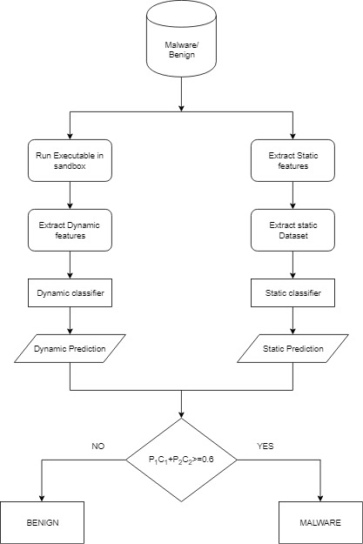

Fig 5.1: High level architecture for proposed system

5.1.1 Static engine
Feature extraction process is the major part of any classification task. The static features are extracted from the binary files and given as input to various classification algorithms. The pestudio library is used to extract the PEHeader data and section data from the executables. These data are then used to construct the dataset for the static classifier. The classifier is then trained and tuned using various machine learning algorithms for the dataset generated. After tuning of the algorithms, the best machine learning model is chosen for the development of the classifier.

5.1.2 Dynamic engine
The dynamic features are extracted by running the executables in an online sandbox named as Amnpardaz Sandbox. This sandbox generates the report in JSON format. It contains the runtime information of the files. The json module of python is used to extract the json data. We use the processes invoked as the features for the dataset. The classifier is then trained and tuned using various machine learning algorithms for the dataset generated. After tuning of the algorithms, the best machine learning model is chosen for the development of the classifier.

5.2 LOW LEVEL DESIGN ARCHITECTURE
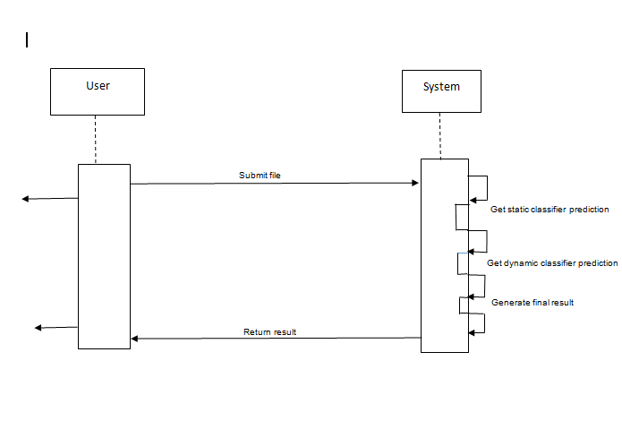
5.2.1 Sequence Diagram/DFD

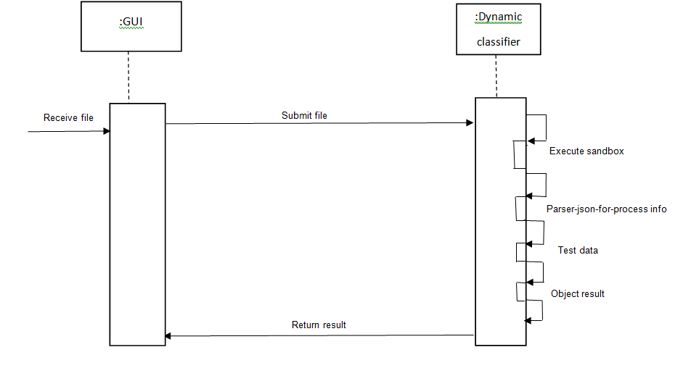
Fig 5.2.1.1: Scenario 1 – User Interaction with the system

Fig 5.2.1.2: Scenario 2 – Working of Dynamic Classifier

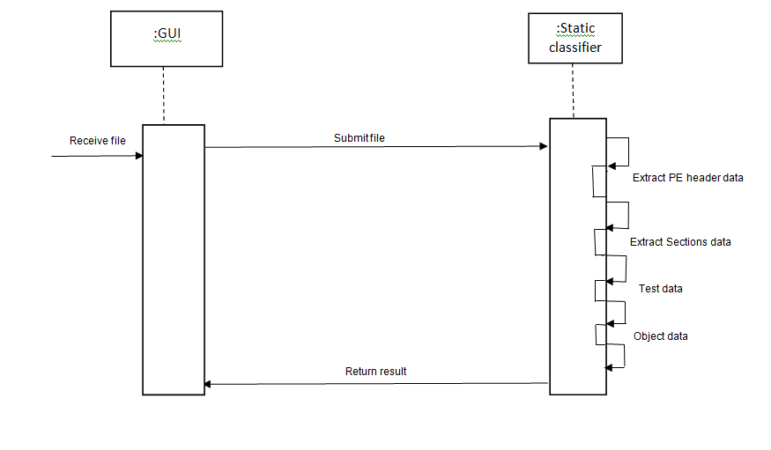

Fig 5.2.1.3: Scenario 3 – Working of the static classifer

5.2.2 Activity Diagram
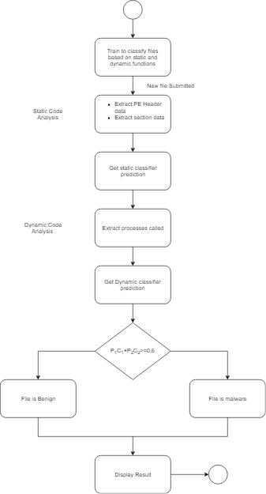

Fig 6.2.2: Activity Diagram

5.2.3 Use Case Diagram

Fig 6.2.3.1: Use Case Diagram for data collection

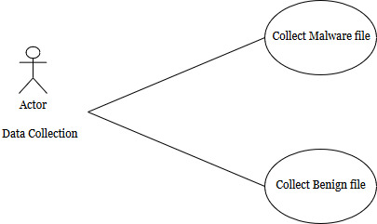

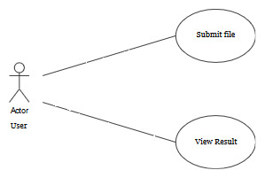

Fig 6.2.3.2: Use Case Diagram for User Interaction with system

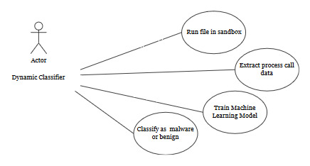

Fig 6.2.3.3: Use Case Diagram for Dynamic Classifier

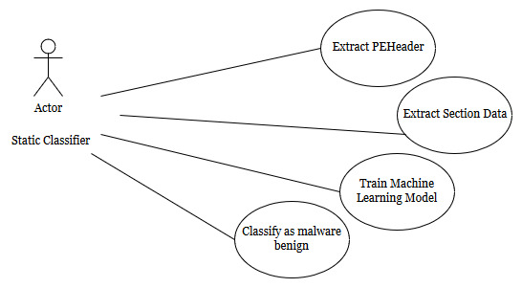

Fig 6.2.3.4: Use Case Diagram for Static Classifier

CHAPTER 6

SYSTEM IMPLEMENTATION
6.1 MODULES
This section deals with the various modules involved in the implementation of the system. We describe each module and its functioning in detail in the following subsections. The malware files are collected from the VirusShare community website.

6.1.1 Static Engine
This module is developed with the aim of building a static classifier to extract static analysis data from the files. A dataset of about 420 benign files and 200 malware files are used to train the machine learning model.

6.1.1.1 Reading_File_Header_Features.ipynb
This module is used to extract the file header features of an executable. The pestudio library is used to extract these features from the file. We then store the data in the related csv files.

6.1.1.2 Reading_DOS_Header_Features.ipynb
This module is used to extract the DOS header features of an executable. The pestudio library is used to extract these features from the file. We then store the data in the related csv files.

6.1.1.3 Reading_Optional_Header_Features.ipynb
This module is used to extract the Optional header features of an executable. The pestudio library is used to extract these features from the file. We then store the data in the related csv files.

6.1.1.4 Reading_Section_info.ipynb
This module is used to extract the file header section features of an executable.
The pestudio library is used to extract the features such as the virtual address, SizeOfData etc, from the file. We then store the data in the related csv files.
6.1.1.5 PEHeader_Classification.ipynb
In this module we construct the dataset by reading the values of the features extracted from the CSV files and create the final header_dataset. We then train various machine learning algorithms based on this dataset. The machine learning algorithm which gives the highest accuracy is selected as the best model and future predictions are made according to it.

6.1.1.6 Sections_Classification.ipynb
In this module we construct the dataset by reading the values of the features extracted from the CSV files and create the final sections_dataset. We then train various machine learning algorithms based on this dataset. The machine learning algorithm which gives the highest accuracy is selected as the best model and future predictions are made according to it.

6.1.2 Dynamic Engine
This module is developed with the aim of building a dynamic classifier to extract dynamic analysis data from the files. A dataset of about 325 benign files and malware files are used to train the machine learning model. We upload the files to an online sandbox (Amnpardaz Sandbox) which returns the details of runtime analysis in JSON format. We use this JSON report to extract the features.

6.1.2.1 Reading_Dynamic_Features.ipynb
This module is used to extract the processes invoked by an executable during its execution. We make use of the JSON library to parse the JSON reports and create the final dynamic_dataset. We then train various machine learning algorithms based on this dataset. The machine learning algorithm which gives the highest accuracy is selected as the best model and future predictions are made according to it.

6.1.3 GUI
We make use of the standard GUI Python library Tkinter to design a simple and user-friendly GUI. The user uploads the file data to the system with the help of this GUI. After the analysis and the prediction is made by the various classifiers, a final prediction is made and this is then sent as an output to the user.
CHAPTER 7

SYSTEM TESTING

Testing is the process of evaluating a system or its component(s) with the intent to find that whether it satisfies the specified requirements or not. Testing is executing a system in order to identify any gaps, errors or missing requirements in contrary to the actual desire or requirements.

Cross-validation is a statistical method used to estimate the skill of machine learning models. It is used to compare and select a model for a given predictive modeling problem because it is easy to understand and implement and results in skill estimates that generally have a lower bias than other methods.

Stratified cross validation is the splitting of data into folds that is governed by criteria such as ensuring that each fold has the same proportion observations with a given categorical value, such as the class value outcome.

We have used the above mentioned techniques for the purpose of testing the various machine learning algorithms accuracy for our dataset. After the creation of the final static and the dynamic datasets, we trained different machine learning algorithms (KNN,Logistic Regression., SVM, Random Forest and Gaussian Naïve Bayes) on the entire datasets. To test the accuracy of the system, we obtained the predictions made by the various algorithms for the same dataset and computed the accuracy score. This gave us an idea regarding what accuracy could be obtained with different algorithms. However this technique of training and testing over the entire datasets is not an efficient one as the classifier has previously seen all the data and we do not know how it will behave when it encounters new file data and if the accuracy will still hold good.

To overcome the above mentioned limitation, we go for split train and test method. Here we divide the entire dataset into two sets, namely the training set and the testing set. We have split 60% of the dataset into training set and the remaining 40% as the testing dataset. We then train the various algorithms based on this training set. Next we test the accuracy of the algorithms by predicting the values for the testing dataset. This is a better estimate of the accuracy of the algorithms as here we hold back a few values from the dataset and this is not seen by the algorithm. We made use of the k-fold cross validation technique to perform the above technique k(=10) times and computed the average of all the accuracies.

However, in the above process, due to the inequality in the data due to unequal number of benign and malware files, there is a chance that while splitting the dataset into the training and the testing set, only one class of data may be available leading to the development of a wrong model. For this reason, we then tested the models using the method of cross validation and stratified sampling. Here we split the dataset into training and testing set based on the ratio of the classes of data. The class with more data will have more number of instances in the training and testing set and similarly for the class of lower instances. The accuracy thus obtained will be a better metric than the ones obtained previously.

Finally, we tune the parameters of the model with the help of Grid Search Cross Validation technique. Here we find the best parameters by finding the accuracy for different combinations of the parameter values and the combination that gives the highest accuracy is then selected as the tuned parameters of the algorithm.

CHAPTER 8

RESULTS AND DISCUSSIONS

8.1 RESULTS
The static analysis and classification is conducted on 200 malware files and 420 benign files each analysed using the pestudio utility. The experimental environment is set up on a Windows10 machine. In the machine the pestudio library is run for each of the binary files. The analysis output for each file is written into a CSV. From this CSV we construct the feature set. Dynamic feature extraction is done by executing the binary files in Amnpardaz malware analysis system. The malware analyser will produce the JSON report which contains information about the functions invoked.
The following table shows the results of the static and the dynamic classifier.

 |  | KNN | Logistic Regression | SVM | Random Forest | Gaussian Naïve Bayes
Static Engine | PEHeader | 90.28% | 91.73% | 69.36% | 97.16% | 86.06%
Static Engine | Sections | 89.14% | 85.41% | 75.04% | 92.86% | 72.61%
Dynamic Engine | Processes | 94.17% | 93.86% | 94.17% | 94.17% | 94.17%

Table 8.1: Accuracy results obtained for the various machine learning algorithms

8.2 DISCUSSIONS
From the above results, it is clear that the best algorithm for the static engine is the RandomForest Algorithm which has an overall accuracy of 97.16% for the PEHeader classification and 92.86% for the Sections classification. On the other hand, KNN is the best suited algorithm for the Dynamic classifier with an overall accuracy of 94.17% .

CHAPTER 9

CONCLUSIONS AND FUTURE WORK

7.1 CONCLUSION
In this work we have presented an integrated approach that uses both static and dynamic features as well as machine learning algorithms for malware analysis detection. We have proven our thesis that combined static and dynamic features will increase the detection accuracy than stand alone static and dynamic methods. The results shows that the Random forest machine learning technique is best equipped to classify our data. As with the objective of the study, it is clear that the integrated approach increases the detection accuracy. Also the results shows that the method has higher accuracy compared with methods in the literature survey.

7.2 FUTURE WORK
To continue our work, we will extract more static and dynamic features and reduce the number of features to improve the classification efficiency. Feature selection algorithms can be used to reduce the number of features.

REFERENCES

- http://jevereg.amnpardaz.com, Online Sandbox for testing malwares.
.
- http://virusshare.com , Collection of malwares.

- Akira Mori, (2004)“Detecting Unknown Computer Viruses - A New Approach ” Lecture Notes in Computer Science, pp. 226–241, 2004.

- D.Wagner and D. Dean, (2001) “Intrusion detection via static analysis.” IEEE Symposium on Security and Privacy.

- Fred Schneider, (1998) “Enforceable Security Policies.” Technical report.

- H. Sung, J. Xu, P. Chavez, and S. Mukkamala, (2004) “Static Analyzer of Vicious Executables.” In 20th Annual Computer Security Applications Conference, pp. 326–334, 2004.

- J. Bergeron, M. Debbabi, M. M. Erhioui, and B. Ktari, (1999) “Static Analysis of Binary Code to Isolate Malicious Behavior.” In Proceedings of the 8th Workshop on Enabling Technologies on Infrastructure for Collaborative Enterprises (WETICE’99), pp. 184– 189, 1999.

- Jesse C. Rabek, Roger I. Khazan, Scott M. Lewandowski, and Robert K. Cunningham. (2003), “Detection of Injected, Dynamically Generated, and Obfuscated Malicious Code.” In Proceedings of the 2003 ACM Workshop on Rapid Malcode, pp. 76–82, 2003

- Manual Egele, “A Survey on Automated Dynamic Malware-Analysis Techniques and Tools”

- Matthew G. Schultz, Eleazar Eskin, Erez Zadok, and Salvatore J. Stolfo, (2001) “Data Mining Methods for Detection of New Malicious Executables.” In Proceedings of the IEEE Symposium on Security and Privacy, pp. 38–49, 2001.

- Michael Howard, Avi Pfeffer, Mukesh Dalal, Michael Reposa (IEEE 2018), “Predicting Signatures of future malwares”

- Michael Weber, Matthew Schmid, Michael Schatz, and David Geyer, (2002) “A Toolkit for Detecting and Analyzing Malicious Software.” In Proceedings of the 18th Annual Computer Security Applications Conference, p. 423, 2002.

- Mohammad M. Masud, Latifur Khan, and Bhavani Thuraisingham, (2007) “A scalable multilevel feature extraction technique to detect malicious executables.” Information Systems Frontiers.

- Muazzam Ahmed Siddiqui, “Data Mining Methods for Malware Detection”

- Peter Szor, “The Art of Computer Virus Research and Defense.”Addison Wesley (2005) for Symantec Press, New Jersey.

- P. V. Shijoa, A. Salimb (ICICT 2014), “Integrated static and dynamic analysis for malware detection”,International Conference on Information and Communication Technologies.

- R. Sekar, M. Bendre, P. Bollineni, and D. Dhurjati, (2001) “A Fast Automaton-Based Approach for Detecting Anomalous Program Behaviors.” In IEEE Symposium on Security and Privacy.

- Saiyed Kashif Shaukat, Vinay J. Ribeiro (IEEE 2018), ” RansomWall: A Layered Defense System against Cryptographic Ransomware Attacks using Machine Learning Techniques.”

- S. Hofmeyr, S. Forrest, and A. Somayaji, (1998) “Intrusion detection using sequences of system calls.” Journal of Computer Security, pp. 151–180,1998.

- Symantec, (1997) “Understanding Heuristics: Symantec’s Bloodhound Technology.” Technical report, Symantec Corporation.

- Symantec, (1996) “Understanding and Managing Polymorphic Viruses.” Technical report, Symantec Corporation.

- Udayakumar N, Anandaselvi S, Subbulakshmi T (IEEE 2018), “Dynamic Malware Analysis”

- Y. Radai (1992) “Checksumming Techniques for Anti-Viral Purposes.” In Proceedings of the IFIP 12th World Computer Congress on Education and Society - Information Processing ’92 - Volume 2, pp. 511–517, 1992.

